2  GIK Institute of Engineering Sciences and Technology, Topi.
Fall 2025 (FCSE) Final Exam
Tuesday, 30th December 2025, 8:30 am – 11:00 am
Course Code: CS311 | Course Name: Operating Systems
Instructor name: Taj Muhammad Khan |  | Section: C (CS)
Vetter name: |  | Vetter signature:
Student Name: |  | Registration No:

- Read all questions completely before answering any. There are 8 questions (2 pre mid + 6 post mid).
- Whenever asked for an explanation or reasoning, please provide one. Otherwise, you’ll get zero marks.
- In case of any ambiguity, you may make an assumption. Write it but your assumption should not contradict any statement in the question paper or the general common sense knowledge of the course.
- Write the answer in the space below each question. Answers written with pencil will get zero marks.
- Do rough work with pencil and then write final answer with a pen. Use last few pages for rough work.
- Read the whole paper first. Questions will be answered only in the first 30 minutes and in 30 minutes after the 90 mins mark.
.
Time: 150 minutes. Max Marks: 80 (40% of overall grade)

Question | Total Marks | Obtained
Question # 1 | 10
Question # 2 | 10
Question # 3 | 10
Question # 4. [CLO3 à PLO2] | 10
Question # 5. [CLO3 à PLO2] | 10
Question # 6 | 10
Question # 7 [CLO2 à PLO2] | 10
Question # 8 [CLO2 à PLO2] | 10
Total | 80

Question 01:
Assume the following C code is compiled to create the executable program, forkyfork, which is then run on a UNIX system.
#include ...

int main(int argc, char *argv[]) {
int a = 0;
int b = 0;

a++;
if (fork() == 0) {
b +=2;
printf("If!\n");
printf("a: %d\n", a);
printf("b: %d\n", b);

} else {
b++;
printf("Else!\n");
printf("a: %d\n", a);
printf("b: %d\n", b);
}

a++;
if (fork() == 0) {
b++;
printf("If #2!\n");
printf("a: %d\n", a);
printf("b: %d\n", b);

} else {
b++;
printf("Else #2!\n");
printf("a: %d\n", a);
printf("b: %d\n", b);
}

}
- How many processes will be part of the forkyfork program? Briefly describe (one line) how each will be created.

4 processes
(the original parent; one child, A, from the first fork;

Both will call the second fork:
onechild, B, for the parent; a "grandchild" from A performing the second fork).

- Assume a preemptive scheduling policy (the OS does a context switch whenever a high-priority process arrives) in which a newly created process is always given a higher, static priority than any of the existing processes; also assume that processes never voluntarily relinquish the CPU until they exit. What output will the user see on the terminal when they run forkyfork? You may show this output above, next to the code listing.

Solution: The order as well as the values must be correct.

// Explanations in italics
// parent is running, call fork, child A gets higher priority and starts running

If! (child A -- highest priority of child and parent)
a 1
b 2
(A calls fork; its child gets higher priority and starts running)
If #2! (child of child A)
a 2
b 3
(child of A ends)
Else #2! (back to A)
a 2
b 3
(A ends)
Else! (parent -- only active process)
a 1
b 1
(parent calls fork; its child B gets higher priority and starts running)
If #2! (child B)
a 2
b 2
(B ends)
Else #2! (parent)
a 2
b 2

Question 02:

Suppose that the following jobs arrive as indicated for scheduling and execution on a single CPU.
Job Arrival Time Size (msec) Priority
J1 0 12 1 - (Highest Priority)
J2 2 4 3 - (Lowest Priority)
J3 5 2 1 - (Highest Priority)
J4 8 10 3 - (Lowest Priority)
J5 10 6 2 - (Middle Priority)

- (2 marks) Draw a Gantt chart showing FCFS scheduling for these jobs, and calculate the average job waiting time.

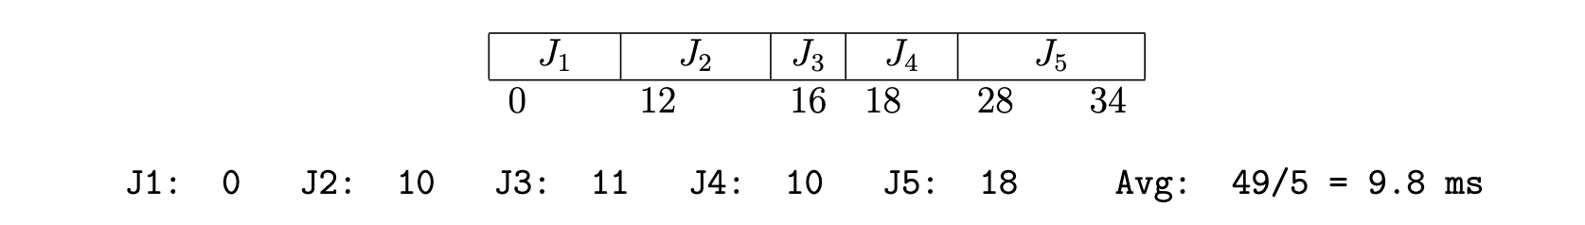

- (2 marks) Draw a Gantt chart showing non-preemptive SJF scheduling for these jobs, and calculate the average job waiting time.

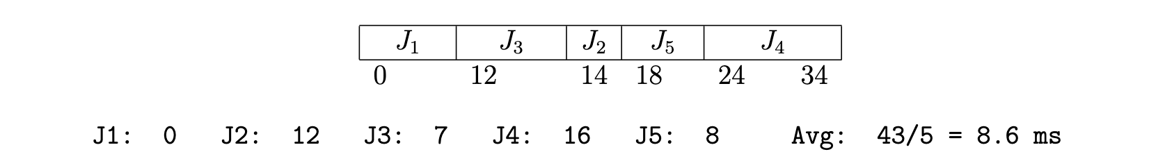

- (2 marks) Draw a Gantt chart showing preemptive SJF (SRPT – Shortest Remaining Processing Time) scheduling for these jobs, and calculate the average job waiting time.

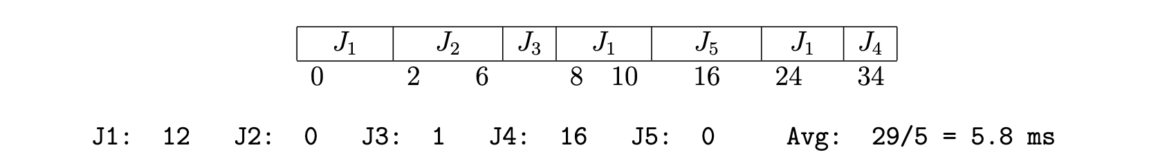

- (2 marks) Draw a Gantt chart showing RR (quantum = 4) scheduling for these jobs, and calculate the average job waiting time.

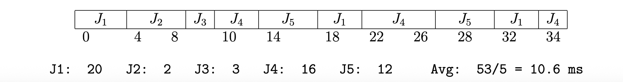

- (2 marks) Draw a Gantt chart showing (preemptive) PRIORITY scheduling for these jobs, and calculate the average job waiting time.

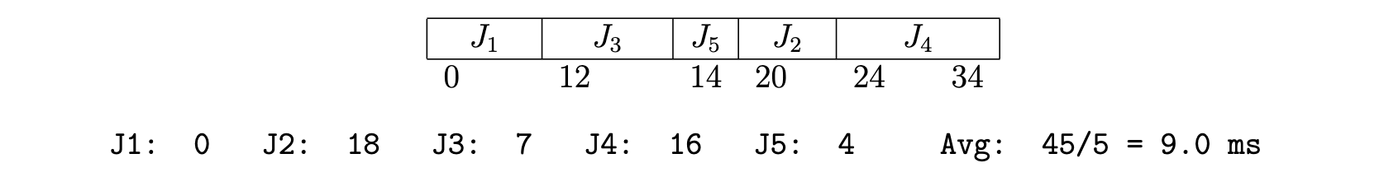
Question 03a:
Assuming none of the system calls fail, what will be the output of the program below? Use a couple of lines to talk about the critical section and race condition in this program.

volatile int balance = 0;
void *mythread(void *arg) {
int i;
for (i = 0; i < 200; i++) {
balance++;
}
printf(“Balance is %d\n”, balance);
return NULL;
}

int main(int argc, char *argv[])
pthread_t p1, p2, p3;
pthread_create(&p1, NULL, mythread, “A”);
pthread_join(p1, NULL);
pthread_create(&p2, NULL, mythread, “B”);
pthread_join(p2, NULL);
pthread_create(&p3, NULL, mythread, “C”);
pthread_join(p3, NULL);
printf(“Final Balance is %d\n”, balance);
}

Answer:

Note that none of the 3 created threads, A, B, and C, run concurrently with one another!
The main thread waits for one to finish (using pthread_join()) before it creates the next
thread. So, there is concurrency and no race conditions!

p1 output: Balance is 200
p2 output: Balance is 400
p3 output: Balance is 600
Main thread output: Final Balance is 600

Question 03b (10 marks):

typedef struct {  int val;  node_t *next;  } node_t;  // assume head points  // to an existing list  node_t *head; | void insert (int val) {  node_t *n = Malloc(sizeof(*n));  n->val = val;  lock(&m);  n->next = head;  head = n;  unlock(&m);  }
int CompareAndSwap(int *address, int expected, int new) {
if (*address == expected) {
*address = new;
return 1; // success
}
return 0; // failure
}

Given the above code for insertion at the head of linked list in a multithreaded code, rewrite the insert() function by replacing the use of locks with the CompareAndSwap hardware instruction. This hardware instruction is atomic and its behaviour is explained by the pseudocode above:

Answer:

We keep trying until we successfully replace the previously read head value with our new node address:

void insert(int value) {
node_t *n = malloc(sizeof(node_t));
assert(n != NULL);

n->value = value;

do {
n->next = head;
} while (CompareAndSwap(&head, n->next, n) == 0);
}
Question 04 [CLO3 à PLO2]:

typedef struct {  threadq_t q;  sem_t s;  } cond_t;  cond_init(cond_t *c){  q_init(&c->q);  sem_init(&c->s, 0);  }  cond_destroy(cond_t *c){  Queue_free(&c->q);  Sem_destroy(&c->s);  } | cond_wait(lock_t *lk, cond_t *c)  {  queue_append(&c->q, get_tid());  lock_release(lk);  sem_wait(&c->s);  lock_acquire(lk);  }  cond_signal(cond_t *c)  {  if (!queue_empty(&c->q)) {  sem_post(&c->s);  }  }

Assume we are on a system which provides locks and semaphores but does not provide condition variables. The above code is an implementation of condition variable cond_wait() and cond_signal(). This implementation uses a queue to store waiting threads’ IDs. This queue has a queue_append() function to add a thread ID to the queue and an queue_empty() function to test whether the queue is empty. There is a semaphore with initial value 0 to block those threads that have to wait. Assume that locks, semaphores and the queue work correctly as intended.

Analyze this implementation to deduce whether it produces the correct condition variable like behavior for cond_wait() and cond_signal(). In case you find any problems, list them all, and for each give a step by step scenario involving multiple threads showing incorrect behavior. If you find that the behavior is correct, justify you answer by explaining how do you think this implementation produces the correct condition variable behavior.

Answer:
The problem of this “solution” is that a cond_signal() to a condition variable in which no one is waiting could have some unexpected effect. In the following execution sequence Thread 1 calls cond_wait() on a condition variable where its TID is queued and the lock is released. Because the lock is released, before Thread 1 can proceed any further, there’s a context switch and Thread 2 acquires it, calls cond_singal(), finds out the queue being non-empty (i.e., Thread 1 waiting), and executes sem_post() in order to release Thread 1. Meanwhile, Thread 1 has not called sem_wait() yet and is not waiting on the semaphore, and, as a result, the count of his semaphore is increased by 1. If a context switch occurs now allowing Thread 3 to run, Thread 3 executes a cond_wait() and queues its TID, and calls sem_wait() to wait. Because of a previous sem_post() on this semaphore by Thread 2 (line 4), Thread 3 does not have to wait at all. Hence, Thread 2 had released a “future” waiting thread (Thread 3) where it should have released Thread 1. This violates the meaning of condition wait and condition signal.

However, the big problem is: Because Thread 1 has not reached its waiting state, the sem_post() should
have no effect. So, this is an incorrect implementation.

 | Thread 1 | Thread 2 | Thread 3 | Comment
1 | cond_wait() |  |  | Semaphore=0
2 | thread1 tid queued
3 | lock_release() |  |  | lock is free
4 |  | cond_signal()
5 |  | sem_post() |  | semaphore = 1
6 |  |  | cond_wait()
7 |  |  | thread3 tid queued
8 |  |  | lock_release()
9 |  |  | sem_wait() | semaphore = 0
10 |  |  |  | Thread3 doesn’t wait!
11 | sem_wait()

Another smaller problem is that while cond_wait() is queueing thread IDs into the condition variable queue, the cond_signal() does not remove them systematically, thus the queue keeps getting ever larger!

Question 05 [CLO3 à PLO2]:
Consider the following snapshot of a system with five resource types R1, R2, R3, R4 and R5, and four processes A, B, C and D:

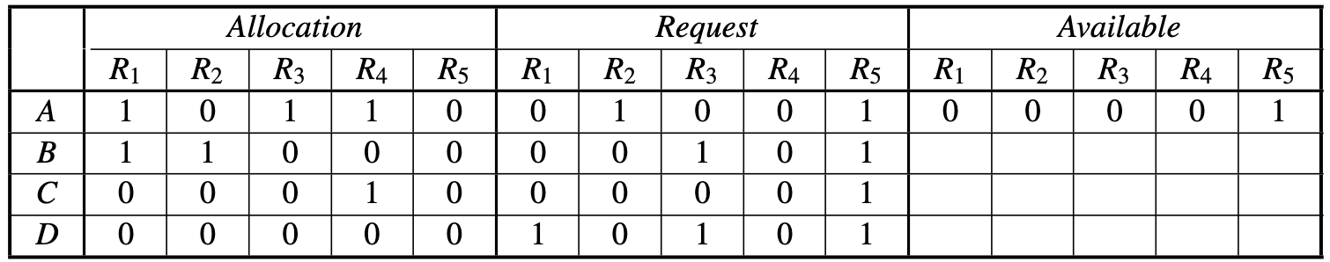

The resources R1, R2, R3, R4, and R5 have 2, 1, 1, 2, and 1 respective instances present in the system. The “Allocation” columns show which resources had been acquired by which processes. The “Request” columns show which process has requested which resources from the system, and the “Available” columns show how many instances of which resource are still free and available for allocation to the processes. The table shows the process A has acquired R1, R3, and R4, and has requested R2 and R5. Similarly for processes B, C, and D. A process can proceed in its execution only after it has acquired all its requested resources. Once it’s done with its execution, it’d free all its acquired resources so that other processes can use them.

The resource allocation graph below is another way to look at the situation. The solid arrows are showing which resources have already been acquired by which processes and the dotted arrows show which processes are waiting to acquire which resources:

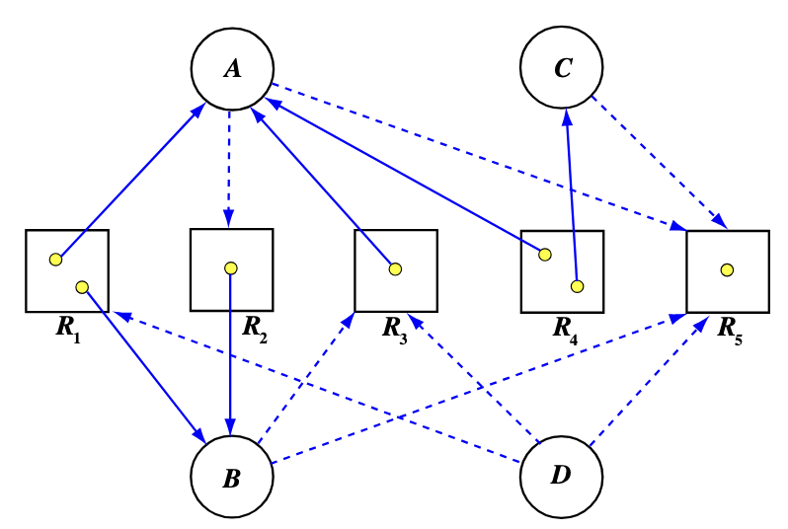

Pretend that you are a scheduler which has the information about the above table and the resource graph.
- Can you try to see if it is possible to satisfy the resources requests of the processes and schedule them for execution in any order? Describe your choices of resource allocation and process scheduling.
- Analyze if there is any deadlock possible? If yes, name the processes involved and why do you think they are in a deadlock?

Answer part 1:

All the processes are waiting for their requested resources to be allotted before they can proceed with their executions. There’s only one resources available – one instance of R5. All processes, except C, are waiting to acquire multiple resources. Only C has requested one resource and that happens to be R5.

As a scheduler, I can see that if I grant R5 to C, it will have its request satisfied and can proceed. I do so. C gets its request granted, and proceeds with its execution. Once finished it will release R5 as well as R4. Now the system has two free resources – R4 and R5.

As a scheduler, I see that the processes A, B, and D request R5 but they also request other resources along with it at the same time: A requests R2, B requests R3, and D is asking for R1 and R3. I am stuck now because having only R4 and R5, I cannot satisfy any of these requests to let any of these processes to proceed. Hence we are in a deadlock!

Answer part 2:

As mentioned above, we are in a deadlock. The processes involved are A, B, and D. R5 is available but:

A has R1, R3, and R4 but requires R2 which is held by B

B has R1, R2 but requires R3 which is held by A.

This causes a circular wait: A reuires R2 held by B which requires R3 held by A.

D is waiting for A and B to release R1 and R3 to then acquire R5 and proceed.
Question 06:
Consider a disk with the following characteristics:
• Number of surfaces: 2
• Number of tracks / surface: 128 K. (1K == 1024)
• Number of bytes / track: 2 MB. (1M == 1K * 1K)
• Number of sectors / track: 1 K

1) How many heads does this disk have?

Two heads – one for each surface.

2) What is the size of each sector?

Track size = 2MB, Sectors/track = 1K
Sector size = 2MB/1K = 2K = 2048.

3) How many bytes per cylinder?

Track sizes = 2MB
Tracks/cylinder = 2. Because there are 2 surfaces and a cylinder is composed of tracks on all surfaces which are equidistant from the center.
Bytes / cylinder = (tracks/cylinder)*track_size = 2 * 2MB = 4MB

4) What is the total capacity of this disk?

Disk capacity = num_surfaces * tracks/surface * bytes/track
= 2 * 128K * 2MB = 512GB

Now assume a stream of requests arrives for this disk; the requests are for cylinder numbers: 20, 5, 8, 9, 2, 30, 35, 40, and 3. The seek distance is the number of cylinders covered in one seek, i.e. when moving from cylinder 5 to cylinder 8, the head will cover a seek distance of 3 (8-5 = 3). Assume the initial position of the disk head is at cylinder 12 and moving towards higher cylinders.

5) With a FCFS scheduling policy, in what order will the requests be serviced?

FCFS (Frist Come First Served) policy will serve the requests in the order they arrive:
20, 5, 8, 9, 2, 30, 35, 40, and 3

6) With a FCFS scheduling policy, what is the total seek distance?

8 + 15 + 3 + 1 + 7 + 28 + 5 + 5 + 37 = 109

7) With a SSTF scheduling policy, in what order will the requests be serviced?

SSTF (Shortest Seek-Time First) will serve the request nearest to the current position first:

9, 8, 5, 3, 2, 20, 30, 35, 40

8) With a SSTF scheduling policy, what is the total seek distance?

3 + 1 + 3 + 2 + 1 + 18 + 10 + 5 + 5 = 48

9) With a SCAN scheduling policy, in what order will the requests be serviced?

SCAN policy will sweep the surface entirely in one direction before moving in the reverse direction, and so on. Since currently the head’s at cylinder 12 and moving towards higher cylinders we continue in that direction:

20, 30, 35, 40, 9, 8, 5, 3, 2

10) With a SCAN scheduling policy, what is the total seek distance?

8 + 10 + 5 + 5 + 31 + 1 + 3 + 2 + 1 = 66

(There can be a technicality here: we don’t know whether the head goes really till the end – we don’t know the surface radius whether when restarting it starts seeking from zero. Ignoring this.)

11) With a C-SCAN scheduling policy, in what order will the requests be serviced? Head moves from lower to higher cylinders.

In the C-SCAN policy, the head moves only in one direction. It’ll sweep the surface until the end in that direction and then go the start, sweep the surface in that direction till the end again, and so on. Since the head’s at cylinder 12 and moving towards higher cylinders:

20, 30, 35, 40, 2, 3, 5, 8, 9

12) With a C-SCAN scheduling policy, what is the total seek distance? Head moves from lower to higher cylinders.

8 + 10 + 5 + 5 + 38 + 1 + 2 + 3 + 1 = 73

(There can be a technicality here: we don’t know whether the head goes really till the end – we don’t know the surface radius whether when restarting it starts seeking from zero. Ignoring this.)
Question 07 [CLO2 à PLO2]:
Imagine you have an FFS-like file system that is appending to a file and, in doing so, must update an inode, the data bitmap, and a data block. Assume this initial system does not perform any journaling. Analyze What happens if a crash occurs after only updating the following block(s)? For each case, uou must state whether the system will be in a consistent state or not? If not, why not? Whether any data, or disk space will be lost?

- Only the data bitmap

Only the data bitmap was written so that block has been marked as in-use. Since it won’t actually be used by anyone so it won’t get free’d. Therefore that block is lost for ever. System is in inconsistent state.

- Only the data block

Only the data block was written. Since it’s not marked as in-use in the data bitmap, sometime later some other file will claim it and overwrite it with its own data. The original data will be lost but the system is consistent.

- Only the inode

Only the inode has been written. This inode will point to a data block which is not in-use in the system and may later contain some other file’s data. Thus this file’s inode will point to that file’s data eventually. System is inconsistent.

- Only the data bitmap and the data block

Only the data bitmap and the data block were written. The data block has been marked in-use in the bitmap but is not pointed to by any inode so can’t be accessed. System is inconsistent.

- Only the data bitmap and the inode

Only the data bitmap and the inode were written. The inode points to this data block and it’s marked as in-use in the data bitmap. But since data was not written in the block, the inode will point to some old garbage data. System is inconsistent.

- Only the data block and the inode

Only the data block and the inode were written. The inode points to this data block and it’s marked as not-in-use in the data bitmap. But eventually it’ll be allotted to some other file which will write its own data in it. Thus this inode will point to that file’s data. System is inconsistent.

Question 08 [CLO2 à PLO2]:
Assume the same system in Question 7 but this time with a basic implementation of full-data journaling, with a transaction header block and a transaction commit block. Assume the system crashes after the following number of blocks have been written to disk; what will be the behavior of the file system when it reboots. Analyze to state whether recovery will be run or not? After the recovery is run (or not), what will be the state of the system, i.e., inconsistent, consistent but will contain old data, consistent and will contain new data, or any other combination.

- 1 disk write (just transaction header)

Since only the transaction header was written before the crash, on reboot the system will recognize that the transaction is incomplete and no replay it. There will be no recovery. System will be consistent containing old data.

- 4 disk writes (transaction header, plus 3 blocks (inode, data bitmap, data block) to journal)

Since the transaction commit was not written before the crash, on reboot the system will recognize that the transaction is incomplete and no replay it. There will be no recovery. System will be consistent containing old data.

- 5 disk writes (transaction header, plus 3 blocks to journal, plus transaction commit)

Since the transaction commit was written before the crash, on reboot the system will recognize that the transaction is valid and replay it. Data will be recovered from the log. System will be consistent containing new data.

- 6 disk writes(5 above plus the checkpoint is completed)

Since the checkpoint was completed before the crash, the transaction will have been removed from the log. On reboot the system will find the log empty and do no recovery. System will be consistent with new data.

- For this part assume that the system is using log structured file system and it crashed in the middle of writing the checkpoint region (CR).

Since the system crashed in the middle of the CR update, on reboot the system will compare the timestamps and see that this CR is invalid, it will then go to the other, older, CR (there are CR copies in log structured file systems placed at opposite ends of the disk and updated alternatively) and access the file system via it. It’ll see if there are any non-checkpointed transactions in the log and replay them updating and repairing the CR. The system will be consistent and any data present in the committed transactions in the log will be recovered.

Rough work.

